PROJECT TITLE: ANALYSING THE PERFORMANCE & EFFICIENCY OF THE RADISSON HOTELS USING DATA VISUALIZATION TECHNIQUES

# INDEX

|  |  |
| --- | --- |
| S.  NO. | CONTENTS |
| 1. | Introduction   * 1. Overview   2. Purpose |
| 2. | Problem definition and Design thinking   * 1. Empathy map |
| 3. | Result   * 1. Worksheets, dashboard and story |
| 4. | Advantages and disadvantages of the project |
| 5. | Applications |
| 6. | Conclusion |
| 7. | Future scope |

1. Introduction:

# 1.1 Overview

The hotel industry is a broad category of businesses that provide lodging services for travellers and tourists .The efficiency and performance will increase that will reinforce customer service. Embedding advanced analytical capabilities to support data driven attribution and optimize digital campaign performance.

# 1.2 Purpose

Radisson Hotel strive to be the first choice in the mind of guests and owners.

The management of the company needs to understand the employee and the customers .Our task is to make a better business and to provide a luxury rooms for the customers.

# Problem definition and design thinking:

2.1 Empathy map

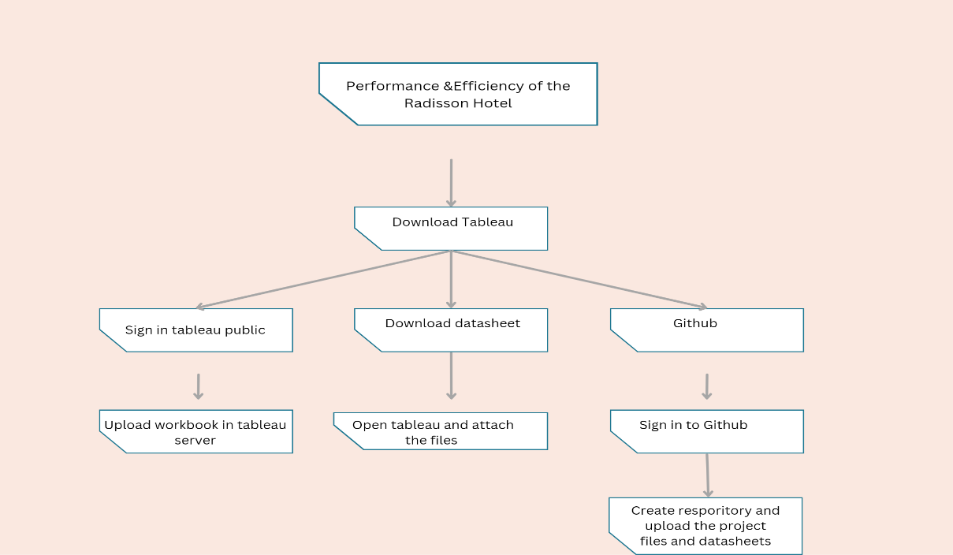

1. Result:

# 3.1 Worksheets, dashboard and story

Below are the five worksheets from TABLEAU representing the following activities:

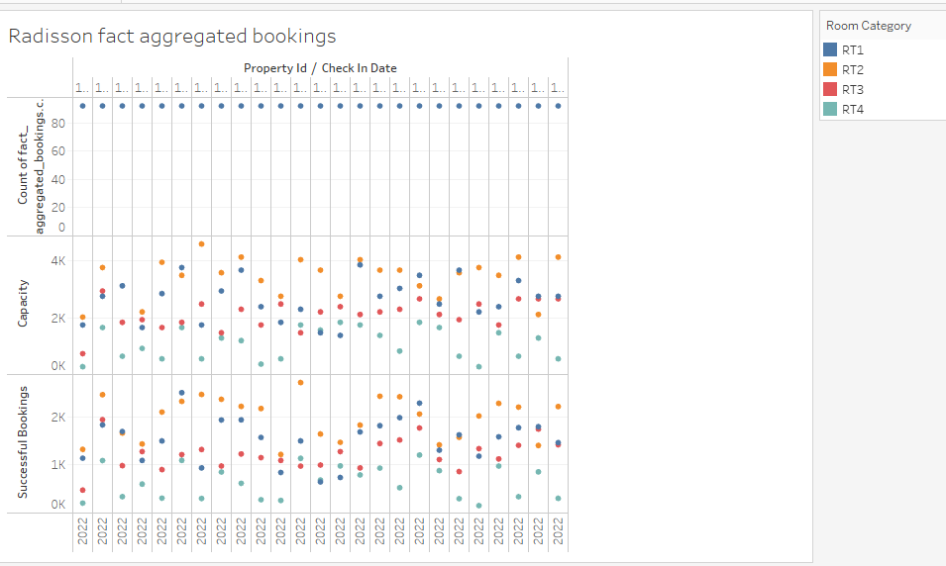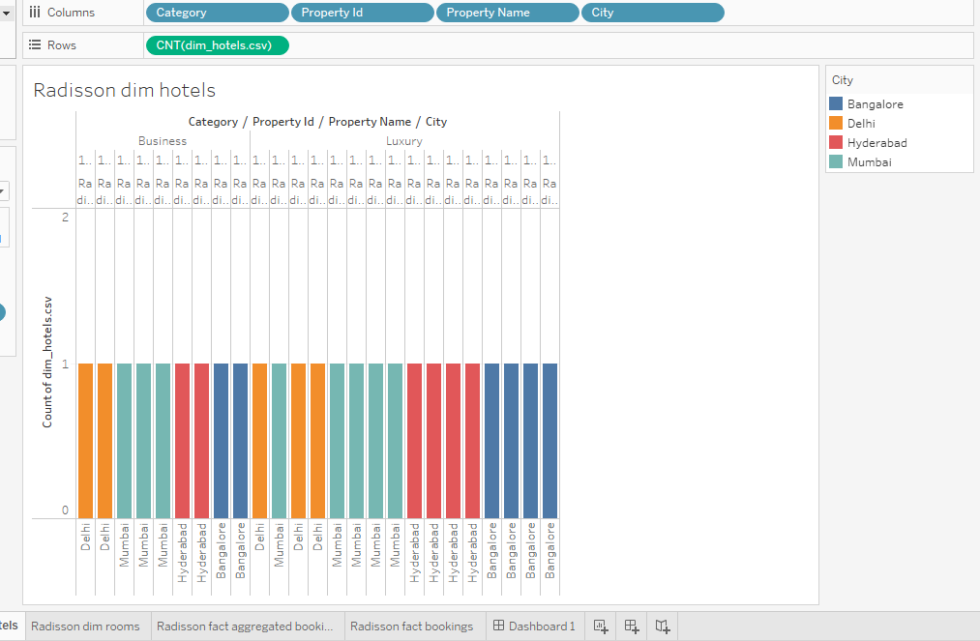 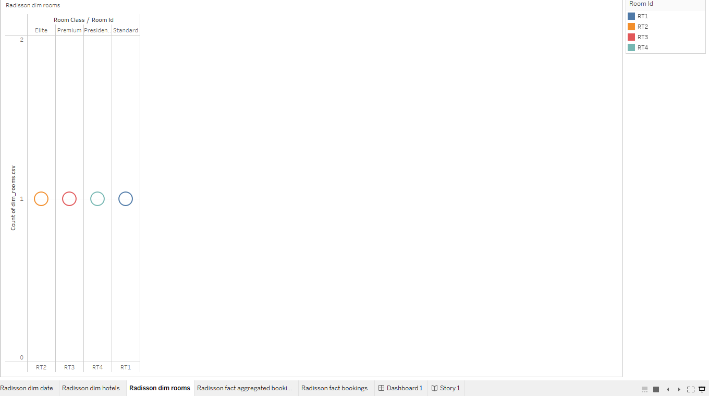 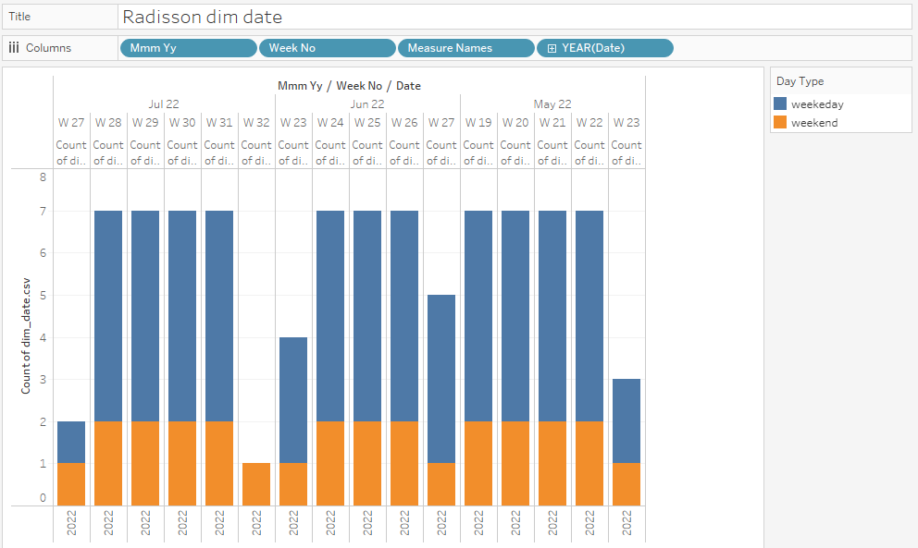

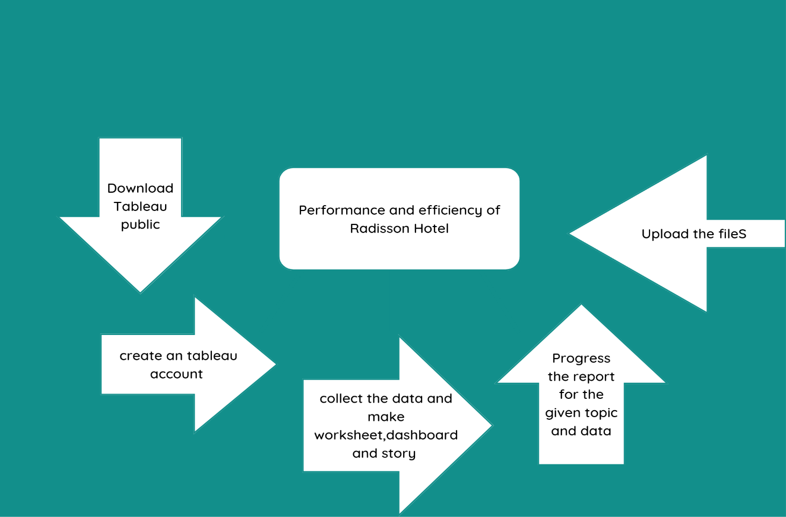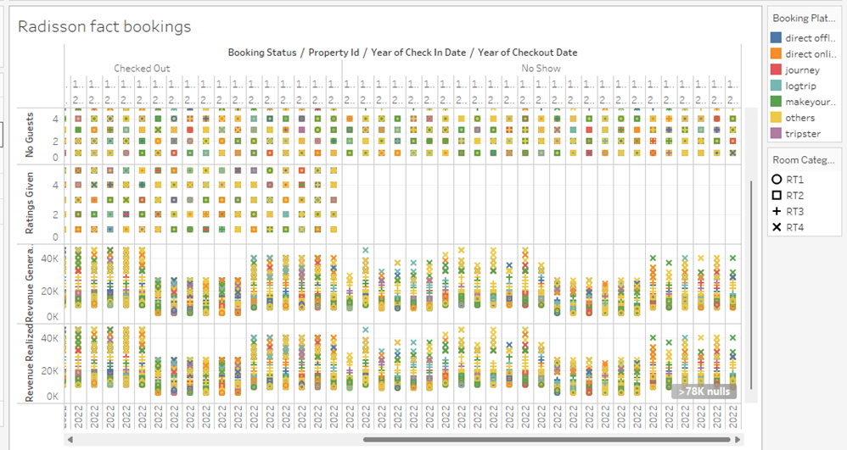BRAIN STROMING MAP

# Dashboards:

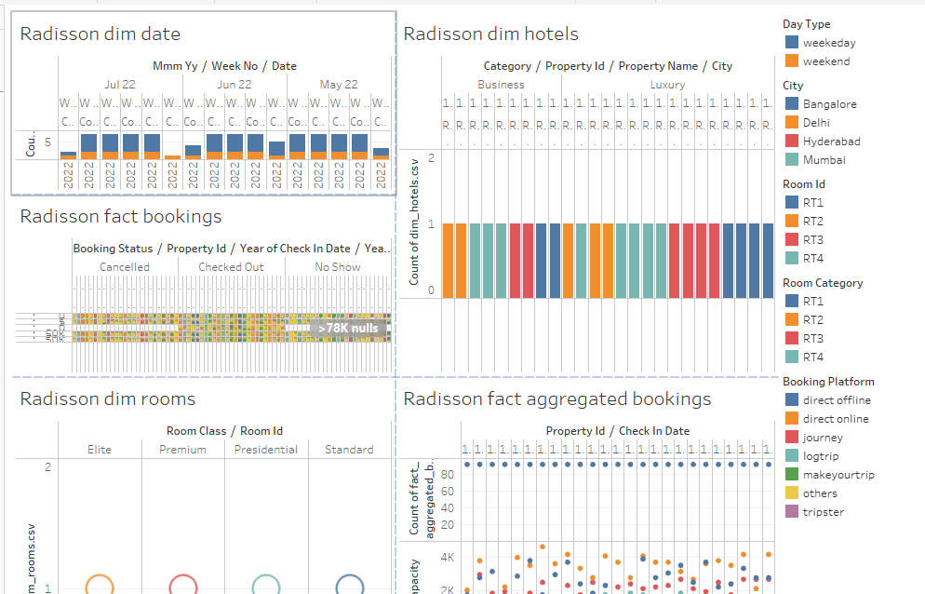

Story:

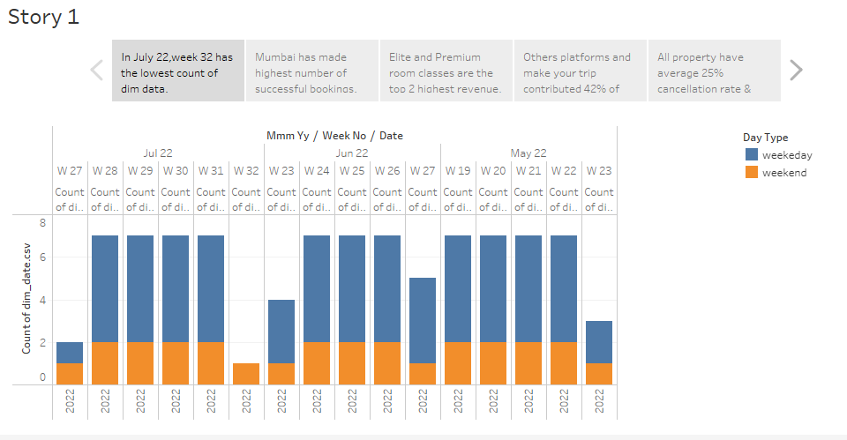

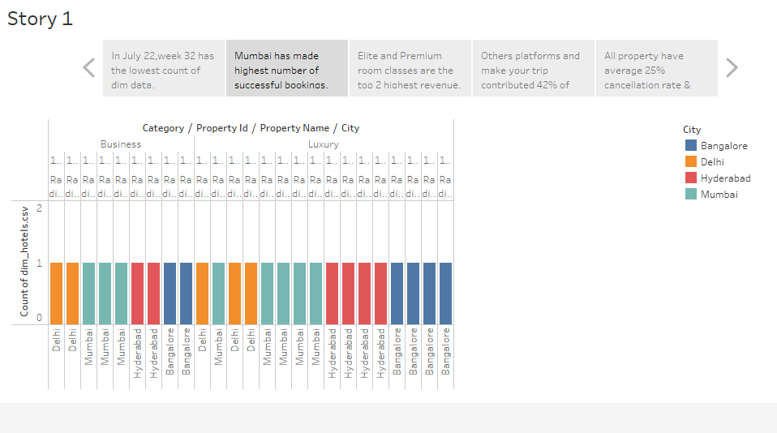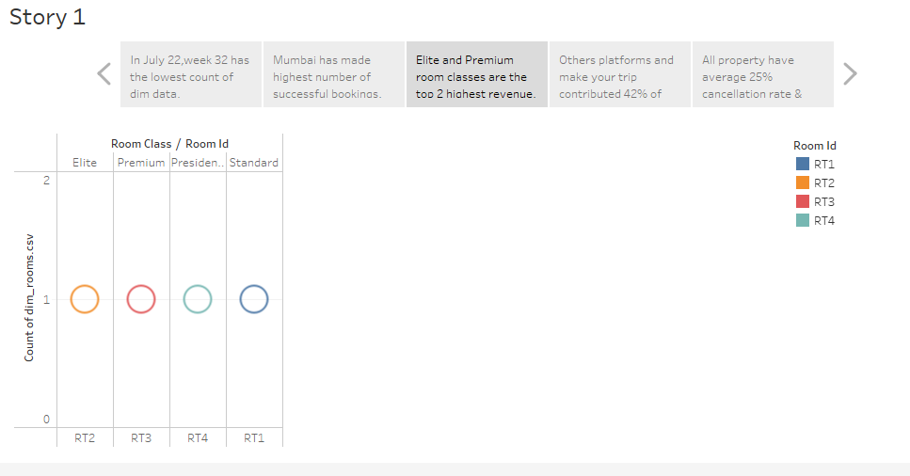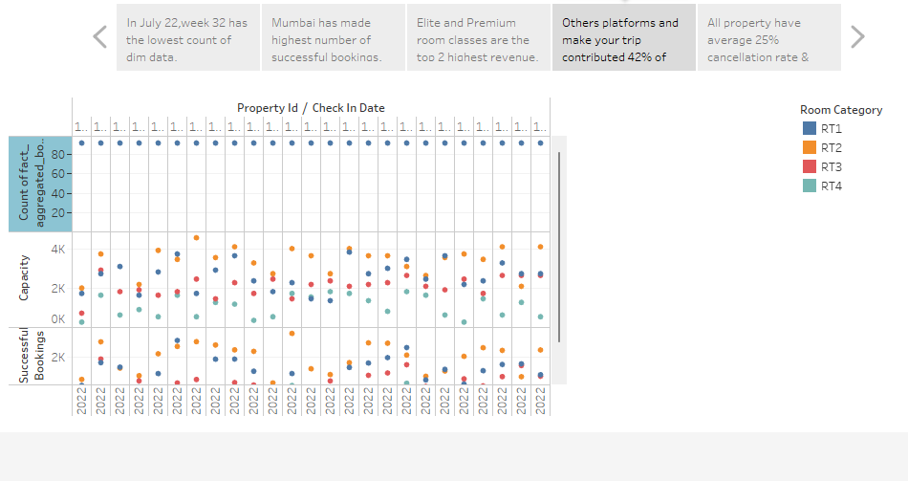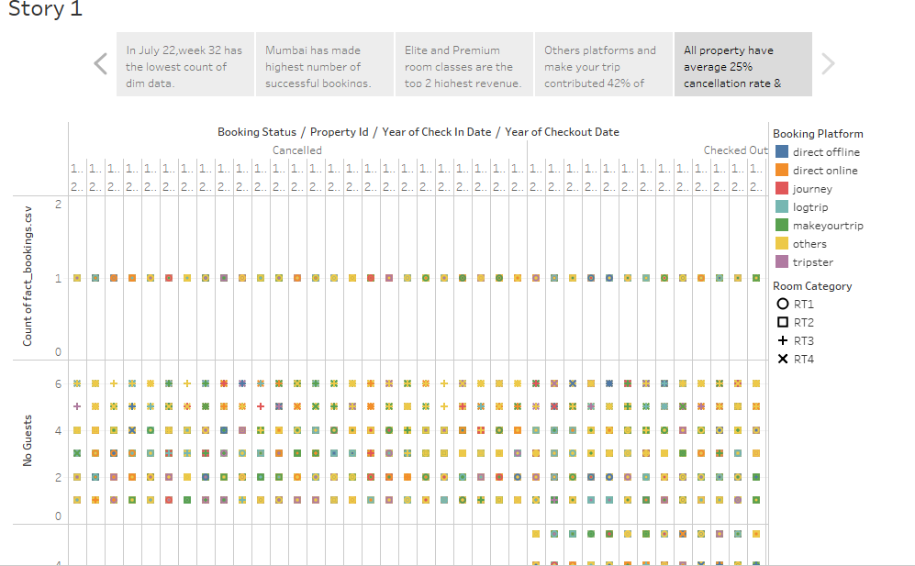

# Advantages and Disadvantages of the project:

Advantages

* Examine previous booking patterns to help increase future occupancy rate. Compare pricing with competitors to develop an effective pricing strategy.
* Analyse guest spending behaviour to identify your most profitable segments and enhanced decision making. Surveys of guests experiences at a hotel are useful sources and can provide insights into booking patterns.

**Disadvantages**

* The biggest disadvantages is over priced and there can be also be a real risk of contact between multicultural colleagues getting lost in translations.
* This type of data visualisation may be ene up with visualisations that don’t properly convey your data . This can lead to confusion and issues doen the line if you use that im

# Applications

* Data analytics in the hospitality industry can help hoteliers to develop a stratergy for managing revenue by using the data gathered from various sources.
* With proper data analysis, Radisson hotel can improvise and make its marketing more effective . Through these data ,they can make predictions that will help owners with forecasting .They would learn about
* Expectation in terms of demand for accommodation in the hotels.
* The best price-value ratio for their guests.

6.Conclusion

* The use of data analytics in the hotel industry is essential for increasing productivity , efficiency and profitability.
* With proper data analysis , the hotel industry can improvise and make its marketing more effective.
* The ultimate goal is to gain is to gain insights and improve performance through data visualisation.
* Whenever someone is looking for a career in the hospitality industry ,they will all think of

Radisson Hotel first.

7. Future Scope

* Having examined the Radisson chain hotels with a help of survey it was distinguished the areas where innovation processes must be realized . Among all, the most important innovation changes supposed to be conducted in improvement of existing and in diversification of new services, in improvement of stuff competence and in creation of specific profitable propositions for guests which will make these guests back again to the hotel .This innovation changes will lead to increasing the economic benefits for hotel enterprises.
* The importance of data analytics in the hotel industry is necessary, since it serves millions of guests everyday. Data analytics in the hospitality industry can help hoteliers to develop a strategy for managing revenue by using the data gathered from various sources.
* Different kind of data can be beneficial in improving revenue management , such as current bookings , past occupancy levels and other key performance statistics.